This document is a draft proposal for development within the Project Scaffold Community (www.projectscaffold.co.za).  The aim is to develop a curriculum for the following purposes:  - Career pathway development for Careworkers.  - A formal, community-led framework for Not-for Credit training post formal qualifications.  All definitions are up for discussion and modification for good motivated reasons. This is what we are currently working with:  - “Module” means a training topic for which specific training material is developed  - “Careworker” is the term used to describe the target of this training and career development, various referred to as Carers, Caregivers, etc  - “Tier” refers to the three levels defined at the moment for Careworker career development and is used to cluster training that should be completed for each Tier.  - “Level” refers to the relative complexity of training modules. There are up to three levels of each topic under this curriculum. For each Module, there is a defined level and tier linked to it. | 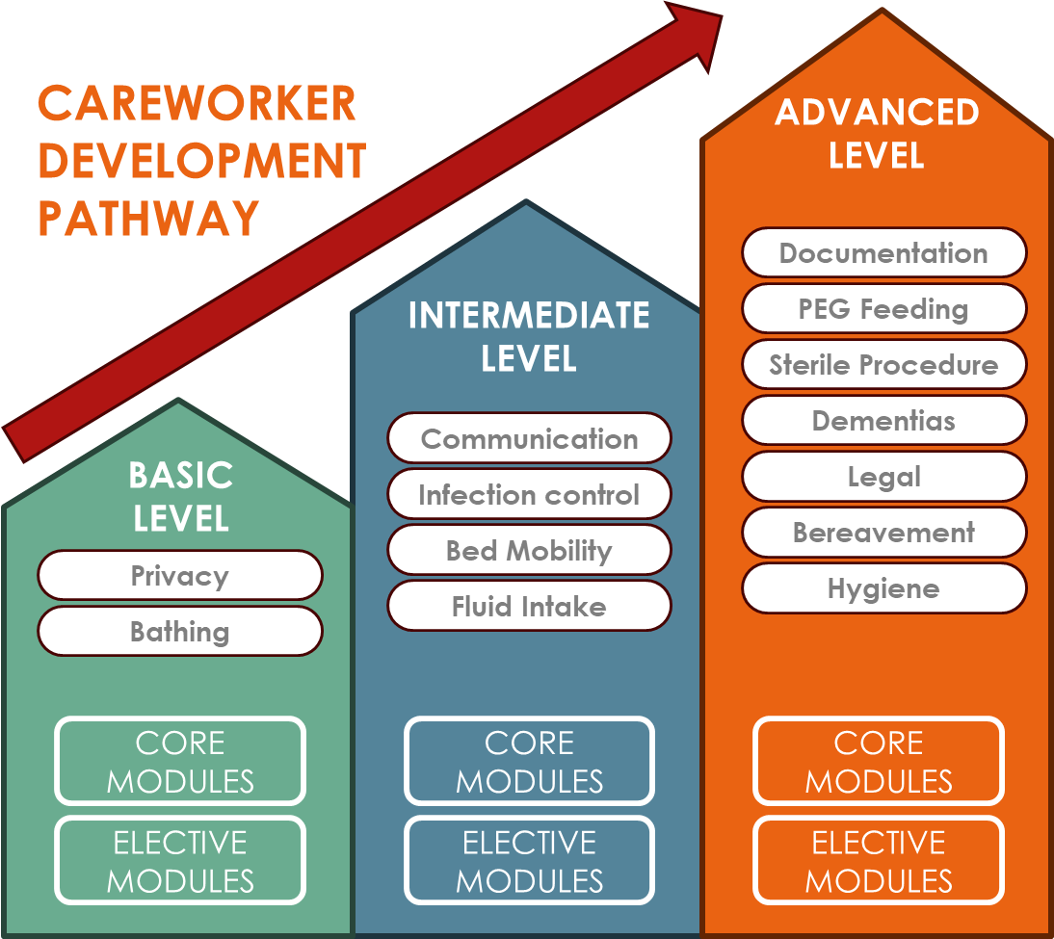  Figure 1:Concept Poster
Members of Project Scaffold are invited to make proposals in terms of this framework, including the addition of modules or the removal of modules that are deemed unnecessary. The initial round of input will end on 31 July 2025, in order to move the process forward as quickly as possilbe.

MODULE NAME | TIERS OF CAREWORKER
 | Basic | Intermediate | Advanced

Who is a Careworker: an Overview
Characteristics of a Careworker | CORE LEVEL B1 | CORE LEVEL I2
Approach to care and support |  | CORE LEVEL I1 | CORE LEVEL A3
Duties of a Careworker | CORE LEVEL B1 | CORE LEVEL I2
Rights and responsibilities of a Careworker | CORE LEVEL B1 | CORE LEVEL I2
Rights and responsibilities of an Older Person | CORE LEVEL B1 | CORE LEVEL I2

Ethical and Legal Considerations
Ethical principles (e.g., privacy) | CORE LEVEL B1 | CORE LEVEL I2 | CORE LEVEL A3
Forms of conduct | CORE LEVEL B1
Legal obligations concerning the Careworker |  | CORE LEVEL I1 | CORE LEVEL A2
Medico-legal risks |  | CORE LEVEL I1 | CORE LEVEL A2
Respecting Privacy and Personal Space | CORE LEVEL B1
Values at work | CORE LEVEL B1
Careworker Contract, JD, Scope |  | CORE LEVEL I1 | CORE LEVEL A2
Policies, procedures and orientation | CORE LEVEL B1
Professional Indemnity |  | ELECTIVE I1 | ELECTIVE A2
OPA and norms and standards | CORE LEVEL B1 | CORE LEVEL I2 | CORE LEVEL A3
Abuse, Restraint, Incidents | CORE LEVEL B1 | CORE LEVEL I2 | CORE LEVEL A3

Communication and Interpersonal Skills
Communication | CORE LEVEL B1
Listening Skills |  | CORE LEVEL I1 | CORE LEVEL A2
PDC Team Communication | CORE LEVEL B1 | CORE LEVEL I2 | CORE LEVEL A3
Overcoming language barriers |  |  | CORE LEVEL A1
Telephone Communication | CORE LEVEL B1
Family Communication |  | CORE LEVEL I1 | CORE LEVEL A2
Cultural Sensitivity and Diversity |  | CORE LEVEL I1 | CORE LEVEL A2
Awareness of Different Communication Norms |  | CORE LEVEL I1 | CORE LEVEL A2
Respecting Privacy and Personal Space | CORE LEVEL B1
Adapting Communication Styles |  |  | CORE LEVEL A1
Professional Boundaries | CORE LEVEL B1 | CORE LEVEL I2 | CORE LEVEL A3

Personal Care and Hygiene
Personal Wellbeing Introduction | CORE LEVEL B1
Bed bath | CORE LEVEL B1
Shower | CORE LEVEL B1
Caring for fingernails and toenails | CORE LEVEL B1 | CORE LEVEL I2 | CORE LEVEL A3
Foot care | CORE LEVEL B1 | ELECTIVE I2 | ELECTIVE A3
Mouth care | CORE LEVEL B1 | CORE LEVEL I2 | CORE LEVEL A3
Hair wash | CORE LEVEL B1 | CORE LEVEL I2 | CORE LEVEL A3
Skin care and integrity | CORE LEVEL B1
Shaving |  | CORE LEVEL I1 | CORE LEVEL A2
Make up/ facial care |  | CORE LEVEL I1 | CORE LEVEL A2
Incontinence Care | CORE LEVEL B1 | CORE LEVEL I2 | CORE LEVEL A3
Bed Pan and Urinal | CORE LEVEL B1 | CORE LEVEL I2 | CORE LEVEL A3
Catheter Care | CORE LEVEL B1 | CORE LEVEL I2 | CORE LEVEL A3
Stoma Care |  | CORE LEVEL I1 | CORE LEVEL A2
Infection Control Practices |  | CORE LEVEL I1
Hand washing | CORE LEVEL B1 | CORE LEVEL I2 | CORE LEVEL A3
Sterile Procedure |  | CORE LEVEL I1 | CORE LEVEL A2
Adapting to Different Hygiene Standards |  |  | CORE LEVEL A1

Mobility and Positioning
Transfer someone who can no longer transfer independently | CORE LEVEL B1 | ELECTIVE I2 | ELECTIVE A3
Sitting in a chair | CORE LEVEL B1
Making a bed | CORE LEVEL B1
Making a bed with someone in the bed | CORE LEVEL B1
Wheelchair use | CORE LEVEL B1
Older Persons in wheelchairs - safety and guidance | CORE LEVEL B1
Accompanying to amenities | CORE LEVEL B1
Bed rest complications | CORE LEVEL B1
Preventing skin tears, skin flaps, pressure sores | CORE LEVEL B1

Nutrition and Hydration
Understanding the importance of optimal nutrition and hydration | CORE LEVEL B1
Fluid intake and output | CORE LEVEL B1 | ELECTIVE I2 | ELECTIVE A3
General rules for feeding Older Persons | CORE LEVEL B1
Serving meals | CORE LEVEL B1
Nasal-gastric tube feeding |  | CORE LEVEL I1 | CORE LEVEL A2
PEG feeding (Percutaneous endoscopic gastrostomy) |  | CORE LEVEL I1 | CORE LEVEL A2
Safe Food Handling and Storage | CORE LEVEL B1
Understanding Dietary Needs and Restrictions | CORE LEVEL B1 | CORE LEVEL I2 | CORE LEVEL A3
Dysphagia - aspiration | CORE LEVEL B1 | CORE LEVEL I2 | CORE LEVEL A3

Observation and Monitoring
Weight monitoring | CORE LEVEL B1 | CORE LEVEL I2 | CORE LEVEL A3
Hydration status | CORE LEVEL B1 | CORE LEVEL I2 | CORE LEVEL A3
Skin integrity | CORE LEVEL B1 | CORE LEVEL I2 | CORE LEVEL A3
Output (Bristol stool chart, urine colour, smell, frequency) | CORE LEVEL B1 | CORE LEVEL I2 | CORE LEVEL A3
Sleep patterns | CORE LEVEL B1 | CORE LEVEL I2 | CORE LEVEL A3
vital observations | CORE LEVEL B1
Urine testing | CORE LEVEL B1 | CORE LEVEL I2 | CORE LEVEL A3
Urine sample collection |  | CORE LEVEL I1 | CORE LEVEL A2

Safety and Prevention
Health and safety | CORE LEVEL B1 | CORE LEVEL I2 | CORE LEVEL A3
Safety for the Careworker |  | CORE LEVEL B1 | CORE LEVEL A2
Care centre safety OHS and Maintenance Awareness | CORE LEVEL B1 | CORE LEVEL I2 | CORE LEVEL A3
Infection Control Practices General | CORE LEVEL B1
Communal infections / PPE | CORE LEVEL B1 | CORE LEVEL I2 | CORE LEVEL A3

EMERGENCY RESPONSE
Emergency Response and Procedures | CORE LEVEL B1
Response cards | CORE LEVEL B1
Emergency drills | CORE LEVEL B1
Responding to a call | CORE LEVEL B1 | CORE LEVEL I2 | CORE LEVEL A3
Answering the phone in an emergency | CORE LEVEL B1
Falls | CORE LEVEL B1 | CORE LEVEL I2 | CORE LEVEL A3
Wounds / Bleeding | CORE LEVEL B1 | CORE LEVEL I2 | CORE LEVEL A3
Unconscious people | CORE LEVEL B1 | CORE LEVEL I2 | CORE LEVEL A3
Allergies | CORE LEVEL B1 | CORE LEVEL I2 | CORE LEVEL A3
Choking | CORE LEVEL B1
Basic fire response | CORE LEVEL B1 | CORE LEVEL I2 | CORE LEVEL A3
Basic first aid | CORE LEVEL B1 | CORE LEVEL I2 | CORE LEVEL A3

Record Keeping and Documentation
Recording and Documentation | CORE LEVEL B1
Record keeping for Careworkers | CORE LEVEL B1 | CORE LEVEL I2 | CORE LEVEL A3
Incident Reporting | CORE LEVEL B1 | CORE LEVEL I2 | CORE LEVEL A3

Medical Assistance and Procedures
Oxygen inhalation | CORE LEVEL B1 | CORE LEVEL I2 | CORE LEVEL A3
Nebulisation |  | CORE LEVEL I1 | CORE LEVEL A2
Basic Understanding of Home Medical Equipment |  | CORE LEVEL I1 | CORE LEVEL A2
Wound dressing (Careworker's role) | CORE LEVEL B1 | CORE LEVEL I2 | CORE LEVEL A3
Medication Assistance (if within scope of practice) | CORE LEVEL B1 | CORE LEVEL I2 | CORE LEVEL A3
Technology in Caregiving |  | CORE LEVEL I1 | CORE LEVEL A2

Specific Older Person Conditions
Sleep | CORE LEVEL B1
Rest | CORE LEVEL B1
Comfort | CORE LEVEL B1
Unconscious Person |  | CORE LEVEL I1 | CORE LEVEL A2
Pain | CORE LEVEL B1 | CORE LEVEL I2 | CORE LEVEL A3
Mood status | CORE LEVEL B1 | CORE LEVEL I2 | CORE LEVEL A3
Distressed reactions - causes and responses |  |  | CORE LEVEL A1
Managing Challenging Behaviours |  |  | CORE LEVEL A1
Emotional Support and Mental Well-being of Older Persons |  |  | CORE LEVEL A1

Understanding Neurocognitive Impairment
Definition of Dementia and impact on care | CORE LEVEL B1 | CORE LEVEL I2 | CORE LEVEL A3
How does communication differ with a person living with Dementia/Communicating with someone who is living with neuro-cognitive impairment | CORE LEVEL B1 | CORE LEVEL I2 | CORE LEVEL A3
Dementia, aggression, and anxiety | CORE LEVEL B1 | CORE LEVEL I2 | CORE LEVEL A3
Knowledge of different types of neurocognitive impairment |  | CORE LEVEL I1 | CORE LEVEL A2
Understanding the three D’s (dementia, depression, delirium) |  | CORE LEVEL I1 | CORE LEVEL A2
Understanding the modifiable risk factors for dementia |  | CORE LEVEL I1 | CORE LEVEL A2

Meaningful Engagement/ RELATIONAL CARE
Enabling vs. disabling practices | CORE LEVEL B1
Creating opportunities for meaningful engagement | CORE LEVEL B1
Engagement in meaningful activities |  | ELECTIVE I1 | ELECTIVE A2
Culture inspiration |  | ELECTIVE I1 | ELECTIVE A2
Activities and Engagement Programming |  | ELECTIVE I1 | ELECTIVE A2
Types of activities | CORE LEVEL B1 | CORE LEVEL I2 | CORE LEVEL A3
Finding the right activity for an Older Person |  |  | CORE LEVEL A1
Importance of exercise – Passive/Active | CORE LEVEL B1 | CORE LEVEL I2 | CORE LEVEL A3
Companionship | CORE LEVEL B1 | CORE LEVEL I2 | CORE LEVEL A1

End-of-Life Care (Palliative)
Care of the dying | CORE LEVEL B1 | CORE LEVEL I2 | CORE LEVEL A3
Palliative care and the Aged |  |  | CORE LEVEL A1
Stages in dying |  |  | CORE LEVEL A1
Bereavement |  |  | CORE LEVEL A1

Careworker Well-being and Self-Care
Work and rest | CORE LEVEL B1 | CORE LEVEL I2 | CORE LEVEL A3
Working hours BCEA |  | CORE LEVEL I1 | CORE LEVEL A2

Skills for Managing a Modern Home Environment
Homecare vs Care Centre |  | CORE LEVEL I1 | CORE LEVEL A2
Homecare and documentation |  | CORE LEVEL I1 | CORE LEVEL A2
Recording of routines and habits for continuity of care |  | CORE LEVEL I1 | CORE LEVEL A2
Basic Appliance Use |  | CORE LEVEL I1 | CORE LEVEL A2
Home Safety and Maintenance Awareness |  | CORE LEVEL I1 | CORE LEVEL A2
Organization and Cleanliness Standards |  | CORE LEVEL I1 | CORE LEVEL A2
Homecare and Housekeeping |  | CORE LEVEL I1 | CORE LEVEL A2
Room neatness and assistance |  | CORE LEVEL I1 | CORE LEVEL A2
Personal Laundry: receiving, sorting, packing away, recording |  | CORE LEVEL I1 | CORE LEVEL A2
Bed, room, closet neatness and maintenance |  | CORE LEVEL I1 | CORE LEVEL A2
Entering and being in a home – Older Person routine and habits |  | CORE LEVEL I1 | CORE LEVEL A2
Kitchen- preparing beverages and meals, hygiene, and appliances |  | CORE LEVEL I1 | CORE LEVEL A2
Respecting Household Routines and Preferences |  | CORE LEVEL I1 | CORE LEVEL A2
Cultural Sensitivity and Diversity |  | CORE LEVEL I1 | CORE LEVEL A2

Time Management and Organization in Home Care
Following Care Plans and Schedules |  | CORE LEVEL I1 | CORE LEVEL A2
Prioritizing Tasks |  | CORE LEVEL I1 | CORE LEVEL A2

Older Person Environment and Preferences
Pets | ELECTIVE B1 | ELECTIVE I2 | ELECTIVE A3
Garden | ELECTIVE B1 | ELECTIVE I2 | ELECTIVE A3

